Data Analytics Internship – Task 1
Sales Performance Analysis
Submitted to: Alfido Tech
Name: Swayam Rajesh Chavan
Domain: Data Analytics Internship
Tools Used: Python, Pandas, Matplotlib, Google Colab
Submission Date: March 2026

1. Introduction
Data analytics is an important process that helps organizations understand patterns, trends, and insights from large amounts of data. By analyzing data effectively, businesses can make better decisions, improve their strategies, and enhance customer satisfaction. In today’s digital world, companies rely on data-driven insights to understand customer behavior, identify market trends, and improve overall business performance.
The objective of this task is to analyze a sales dataset to understand customer purchasing behavior and sales performance across different categories and regions. The dataset contains information about orders, customers, product categories, and sales values. By analyzing these variables, it becomes possible to identify important patterns that can help businesses improve their marketing strategies and product offerings.
The analysis was performed using Python in Google Colab. Various exploratory data analysis techniques and visualizations were used to identify trends and patterns in the dataset.

2. Dataset Overview
The dataset contains sales transaction data including information about orders, customers, products, and regions. Important columns include Order ID, Customer Name, Category, Region, and Sales.
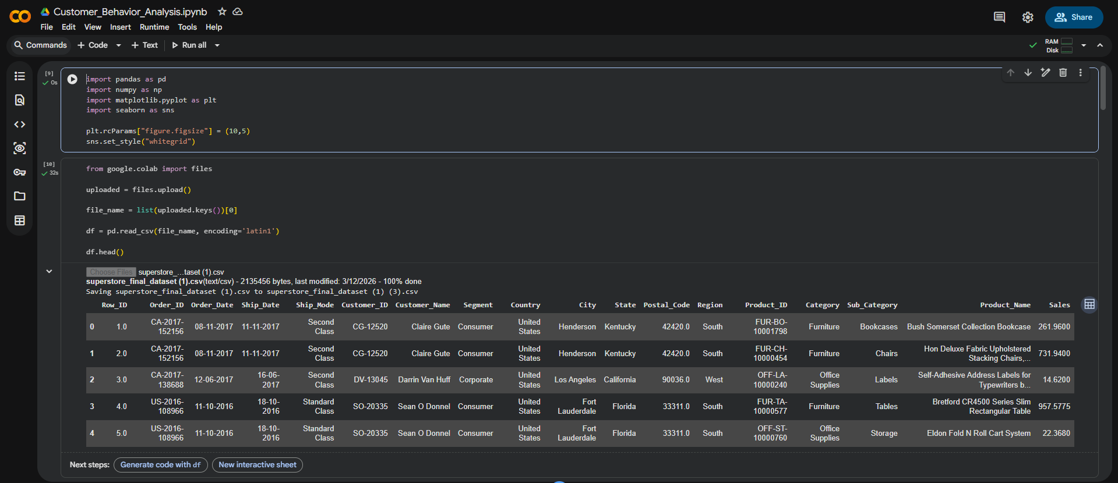
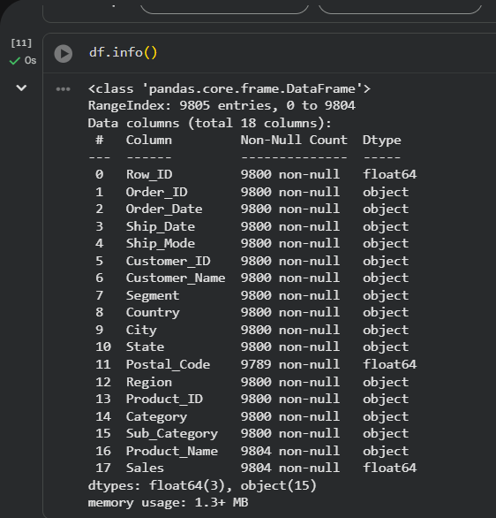

3. Data Cleaning
Data cleaning was performed to ensure data quality. Missing values were checked and duplicates were removed.
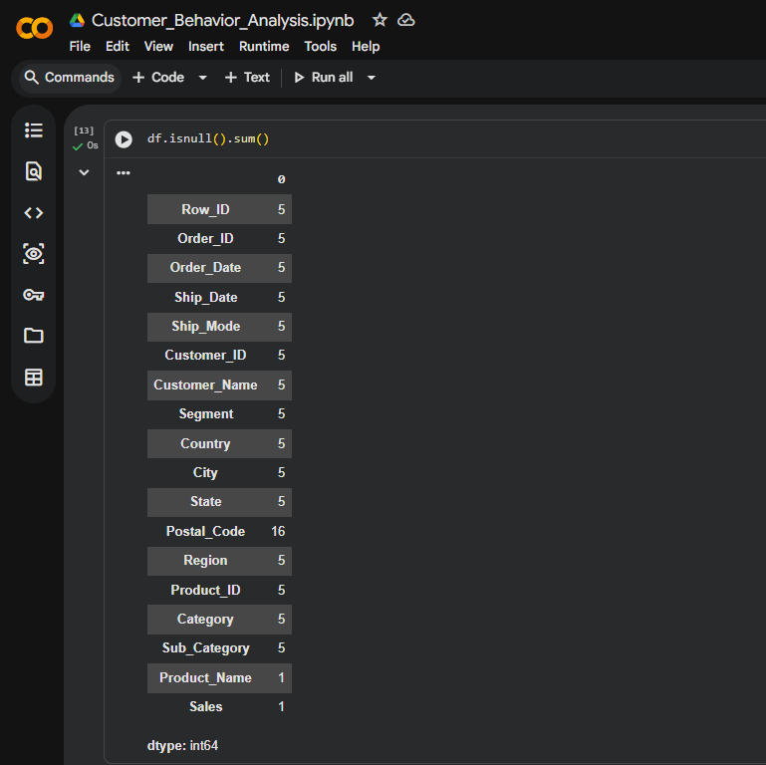

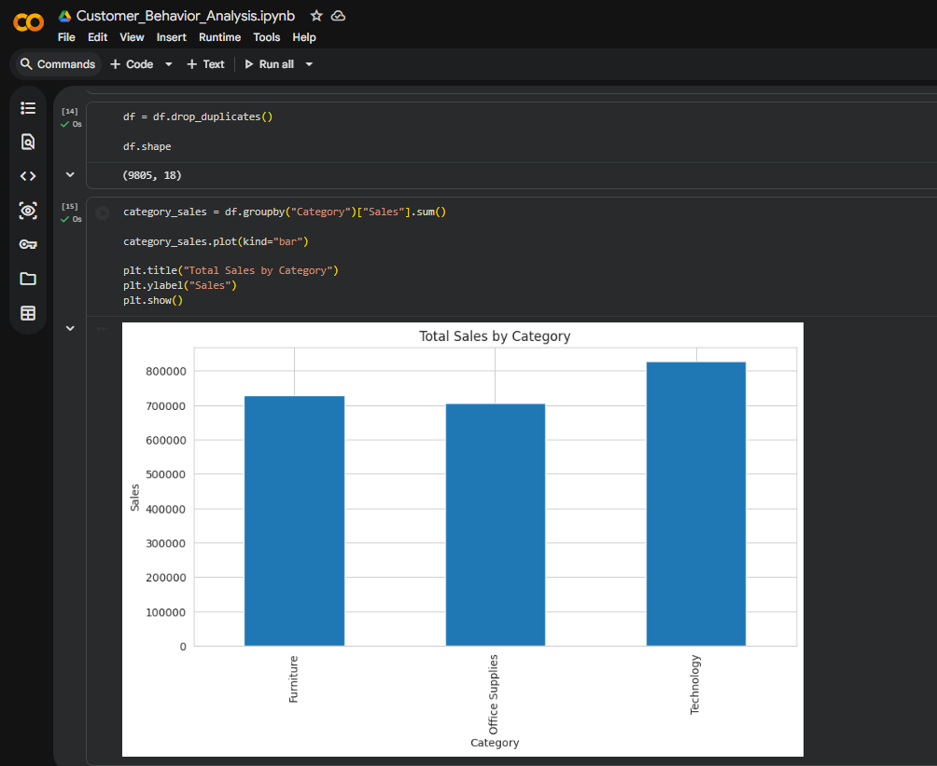

4. Summary Statistics
Summary statistics were calculated to understand the distribution of the dataset.
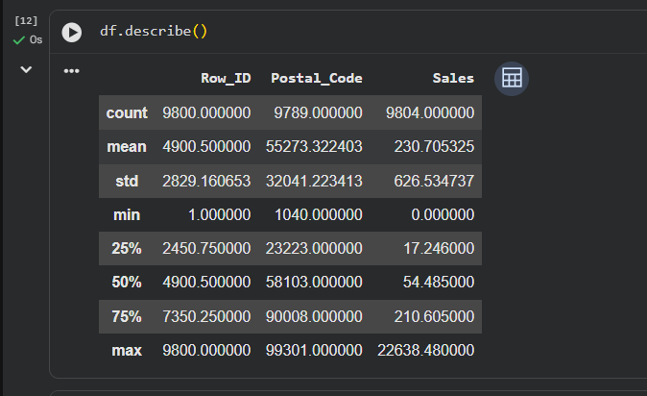

5. Data Visualization


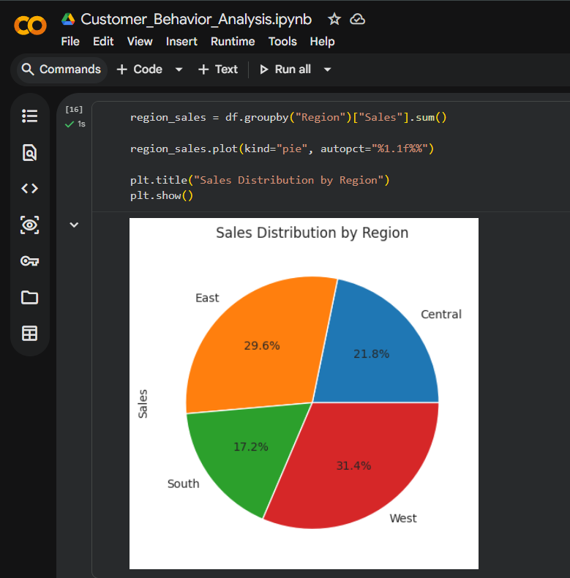
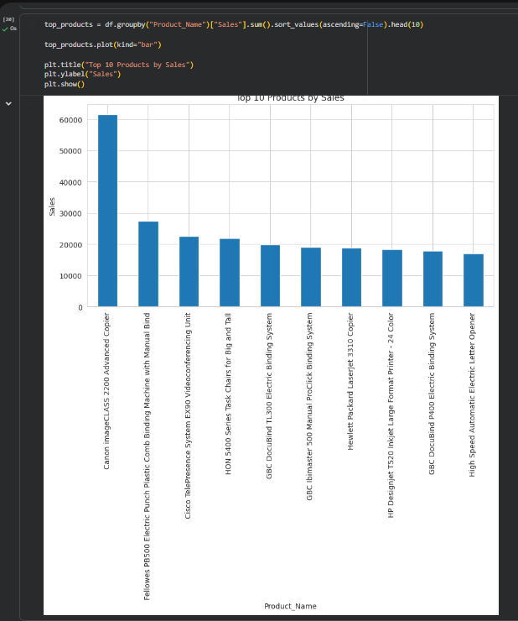
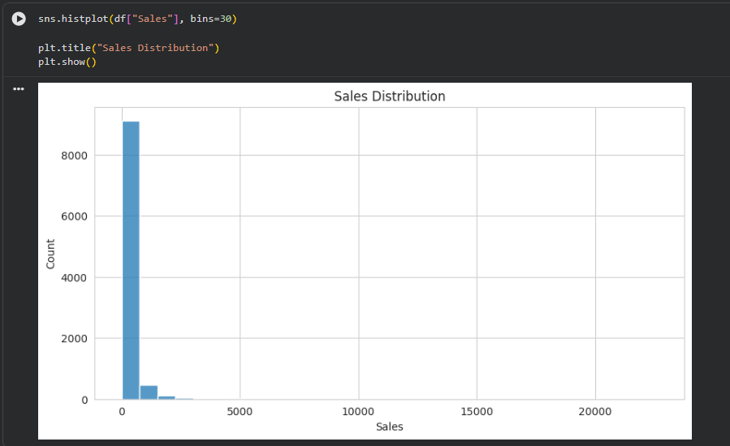
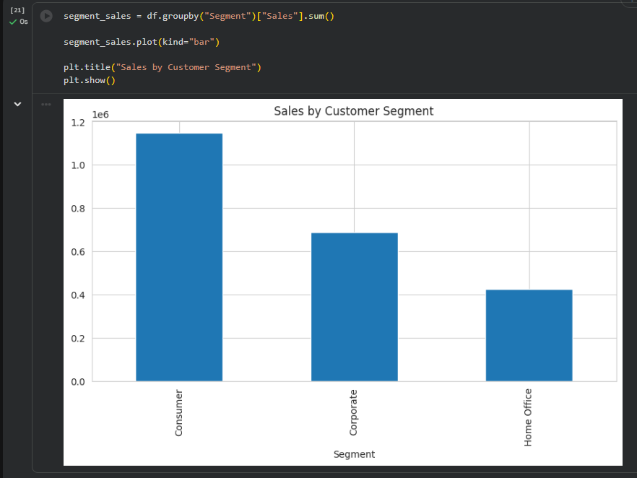

6. Key Insights
1. Technology category generated highest sales.
2. Few products contribute most revenue.
3. Sales vary across regions.
4. Most sales are low-value.

7. Recommendations
1. Focus on high-performing categories.
2. Promote top products.
3. Improve low-performing regions.
4. Introduce loyalty programs.
5. Bundle products.

8. Executive Summary
This project analyzed sales data to identify patterns and trends. Visualizations helped understand category performance and regional distribution. Recommendations were provided to improve business strategies.

